**IT3511 FULL STACK WEB DEVELOPMENT LAB**

**Ex. No : 1**

1. **Develop a portfolio website for yourself which gives details about yourself for a potential recruiter.**

**AIM:**

**To Develop a portfolio website for yourself which gives details about yourself for a potential recruiter using REACT frame work.**

**Algorithm:**

1. **Project Setup:**
   * Use Create React App to initialize your project.
   * Navigate to your project directory.
2. **Create Components:**
   * Create three components: Home, Skills, and About.
   * Each component should have its own **.js** file (Home.js, Skills.js, About.js) and a corresponding **.css** file for styling.
3. **Component Content:**
   * Define the content for each component:
     + Home: A welcome message and an introduction to your portfolio.
     + Skills: List your skills, particularly focusing on the MERN stack.
     + About: Write a brief introduction about yourself, your experience, and your passion for web development.
4. **Styling (CSS):**
   * Update each **.css** file to style the components as desired.
   * Adjust fonts, colors, padding, margins, and other styling properties to create an appealing visual presentation.
5. **App.js:**
   * Import the three components (Home, Skills, About).
   * Structure your App component to include these components in the desired order.
   * This file will serve as the main entry point for your application.
6. **Overall Styling (App.css):**
   * Update **App.css** to style the overall layout of your website.
   * Set a max-width, center the content, and apply any global styling rules you want to maintain consistency.
7. **Running the App:**
   * Use the **npm start** command to launch your React development server.
   * Open your browser and navigate to the provided local development URL (usually **http://localhost:3000**).
8. **Testing and Debugging:**
   * Continuously test your app as you make changes to ensure everything is working as expected.
   * Use browser developer tools to debug and identify any issues.
9. **Customization and Expansion:**
   * Customize the content, styling, and layout according to your preferences.
   * Consider adding additional components for projects, contact information, or other sections as needed.
10. **Deployment:**
    * Once you're satisfied with your portfolio website, you can deploy it to a hosting service.
    * Popular choices include GitHub Pages, Netlify, Vercel, or other hosting platforms.

**Program:**

1. **Index.html**
2. <!DOCTYPE html>
3. <html lang="en">
4. <head>
5. <meta charset="utf-8" />
6. <link rel="icon" href="%PUBLIC_URL%/favicon.ico" />
7. <meta name="viewport" content="width=device-width, initial-scale=1" />
8. <meta name="theme-color" content="#000000" />
9. <meta
10. name="description"
11. content="Web site created using create-react-app"
12. />
13. <link rel="apple-touch-icon" href="%PUBLIC_URL%/logo192.png" />
15. <link rel="manifest" href="%PUBLIC_URL%/manifest.json" />
17. <title>React App</title>
18. </head>
19. <body>
20. <noscript>You need to enable JavaScript to run this app.</noscript>
21. <div id="root"></div>
23. </body>
24. </html>

**2. index.js**

import React from 'react';

import ReactDOM from 'react-dom/client';

import './index.css';

import App from './App';

import reportWebVitals from './reportWebVitals';

const root = ReactDOM.createRoot(document.getElementById('root'));

root.render(

  <React.StrictMode>

    <App />

  </React.StrictMode>

);

reportWebVitals();

**3. App.js**

import React from 'react';

import ReactDOM from 'react-dom/client';

import './index.css';

import App from './App';

import reportWebVitals from './reportWebVitals';

const root = ReactDOM.createRoot(document.getElementById('root'));

root.render(

  <React.StrictMode>

    <App />

  </React.StrictMode>

);

reportWebVitals();

**4. Home.css**

import React from 'react';

import './Home.css';

const Home = () => {

  return (

    <section className="home">

      <h1>Welcome to My Portfolio</h1>

      <p>I am a Full Stack Developer with expertise in the MERN stack.</p>

    </section>

  );

};

export default Home;

**5. About.css**

import React from 'react';

import './About.css';

const About = () => {

  return (

    <section className="about">

      <h2>About Me</h2>

      <p>

        I am a passionate Full Stack Developer specializing in the MERN stack.

        With several years of experience in web development, I have built

        numerous applications that showcase my expertise and skills.

      </p>

    </section>

  );

};

export default About;

**6. Skills.css**

import React from 'react';

import './Skills.css';

const Skills = () => {

  return (

    <section className="skills">

      <h2>Skills</h2>

      <ul>

        <li>React</li>

        <li>Node.js</li>

        <li>Express.js</li>

        <li>MongoDB</li>

      </ul>

    </section>

  );

};

export default Skills;

**7. App.css**

import React from 'react';

import ReactDOM from 'react-dom/client';

import './index.css';

import App from './App';

import reportWebVitals from './reportWebVitals';

const root = ReactDOM.createRoot(document.getElementById('root'));

root.render(

  <React.StrictMode>

    <App />

  </React.StrictMode>

);

reportWebVitals();

**OUTPUT:**

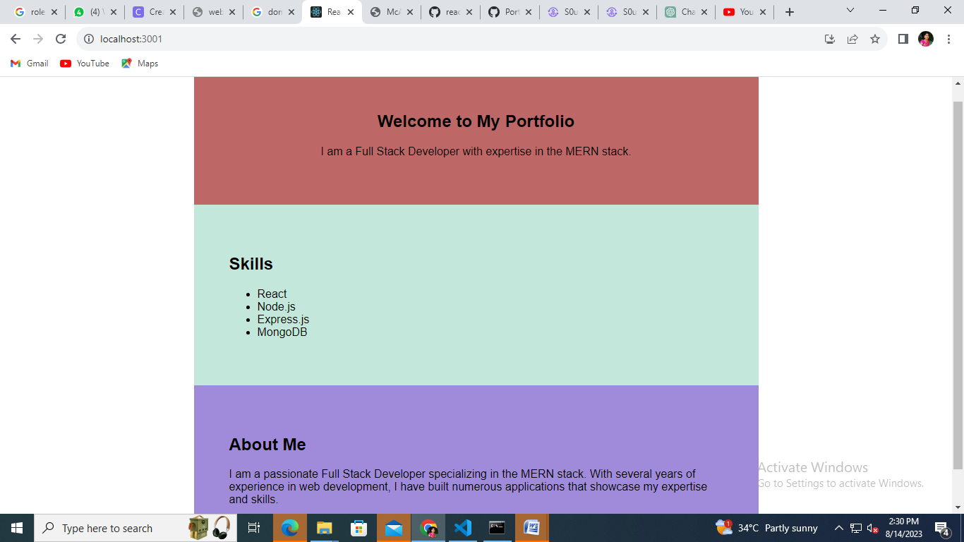

**RESULT:**

**Thus the portfolio website for yourself which gives details about yourself for a potential recruiter using REACT frame work has completed and executed successfully.**